Activity 4.4: Personalising the styling
- Edit css to make the presentation of the web page more personal to you.
- Change the font used on the web page.
- Change the background colour of the header and footer.
- Change the text colour of the header and footer.
- Change the background colour and text colour when the mouse hovers over the hyperlinks in the navigation bar.
- Change the background colour of the section.
- Adjust the width of the section to half the width of the screen.
- Make sure that the section floats to the left of the screen, so that the article displays alongside it.
- Edit ‘lesson4_index.html’ and ‘lesson4_style.css’.
Move the image so that it is inside the section element, immediately after the heading and floating to the right-hand side of the text.
Your finished web page should look something like this:
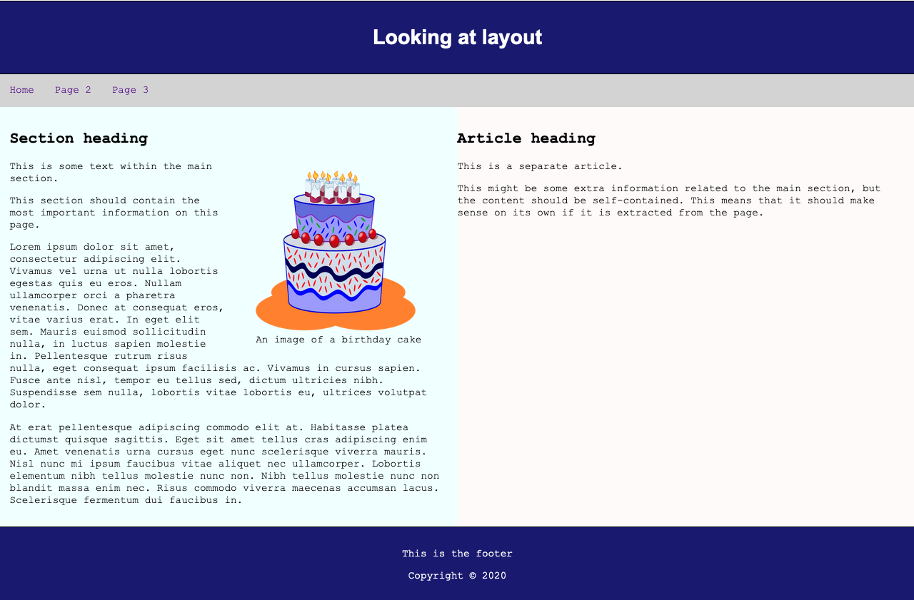

Remember to save both the CSS and HTML file and then open ‘lesson4_index.html’ to view the results. Take a screenshot of the web page and insert it here:

